Neuroscience Minor: 4-Year Plan Date:___________________

Year 1
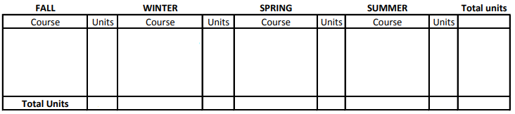
Year 2
Year 3
Year 4
Please Note:
- All minor courses must be taken for a letter grade, with an overall grade-point average of 2.0 or better
- Max 2-course overlap permissible between the student's major and the Neuroscience Minor
- May apply Neuroscience 199AB toward the minor. These 199s, however, may not be used as overlap with the major
- Students may add the Neuroscience minor if it does not cause them to exceed their unit maximum. If they will exceed the max, students must first file a petition with the College of Letters and Science to raise their unit max. Please see a counselor in your appropriate counseling unit (i.e. College Counselors in A316 Murphy Hall or AAP, Athletics, Honors, etc.).

