Neuroscience Major: 4-Year Plan Date:___________________

Year 1
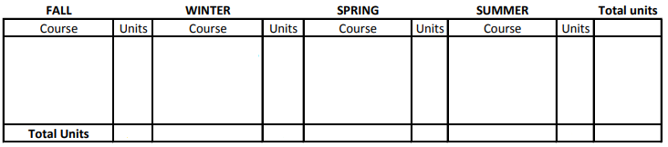
Year 2
Year 3
Year 4
Notes/Action Items:
Keep in mind:
- GE, Writing I/II, & language requirements
- Upper division units requirements (60)
- Extracurricular Plans/Responsibilities
- Must have min 180 units max 216 units to graduate (AP and IB credit can exceed max by amount of that credit)

